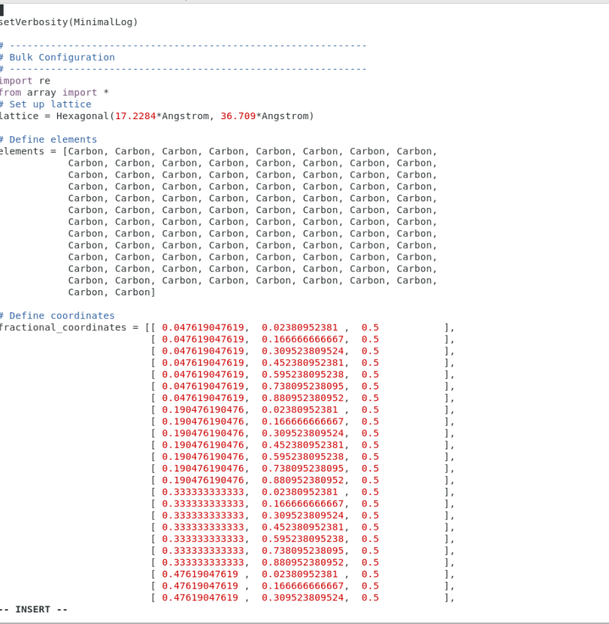

Mesh grid optimization code

K optimization code